Contents
1. Viewing the Applicant Login page 1
2. Updating the Login section 2
3. Message templates 5
Standard message 5
Downtime message 5
Closure Periods message 6
Decoding html 7

Knowledge Article: System Downtimes (not yet written)

Document Version Control
Change History/Review Details
Date | Version | Review by | Summary of Change
6/2/20 | 1.0 | HC | Created for V26
6/11/20 | 2.0 | HC | Updated for V28
08/12/20 | 2.1 | SB | Update the standard HTML following change #20012074
15/12/21 | 2.2 | HC | Updated with Portal Navgiation
23/11/23 | 2.3 | MO’S | Update to Standard message. Include Decoding HTML section to include boxing text. Change # 20016612

It is sometimes necessary to update the message visible to job applicants on the Applicant Login Page, for instance when the e-Recruitment system needs to be taken down for maintenance. This change should be included as part of any downtime plan and scheduled accordingly.

Viewing the Applicant Login page

  - To view what is visible to job applicants, go to www.recruit.ox.ac.uk and click on Login on the left side of the screen:

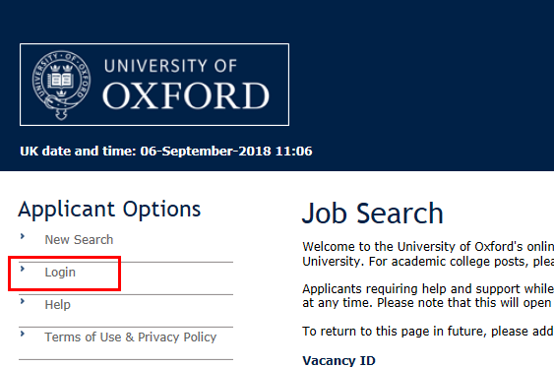

  - The Login page opens:

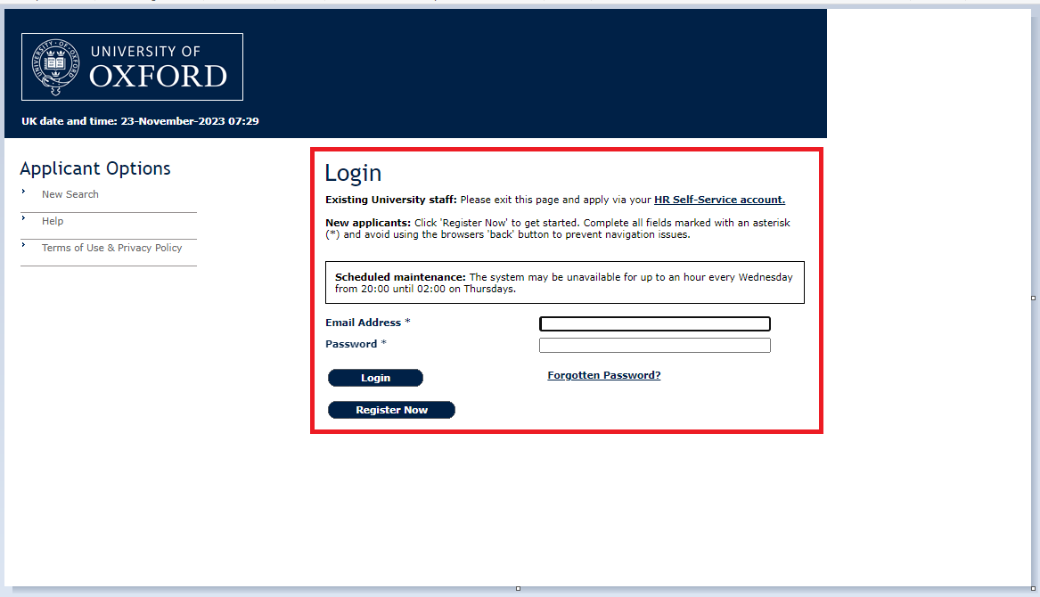

Updating the Login section

Navigate to: Staff Portal > Recruitment Dashboard

  - From the Dashboard, click on Toolbox then choose Recruitment Admin.

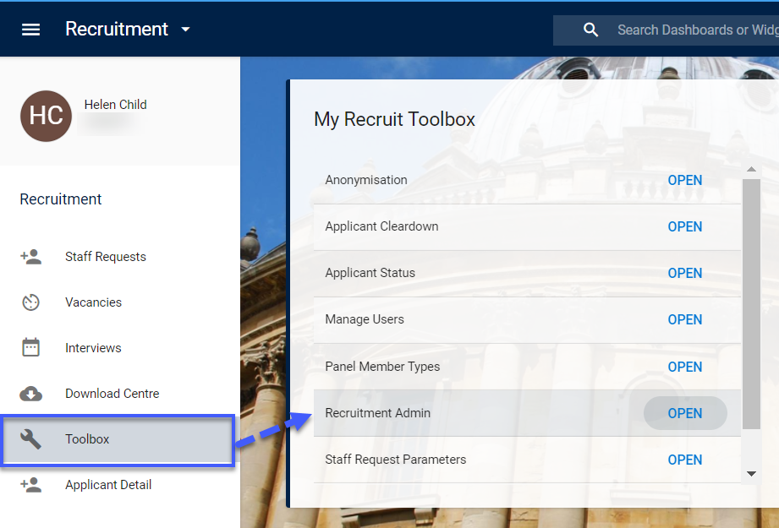

  - Click on Recruitment Admin.

The E-Form Maintenance screen will open.

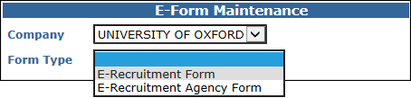

  - Select UNIVERSITY OF OXFORD and E-Recruitment Form.

The form will open to show the individual sections.

 | Any changes you make here will apply to all application forms. If you wish to make changes to an individual application form, follow HOW TO maintain online application forms.

  - Click on the Login Section.

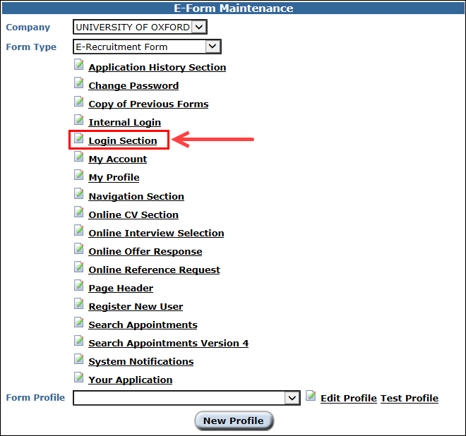

The Login Section screen will open.

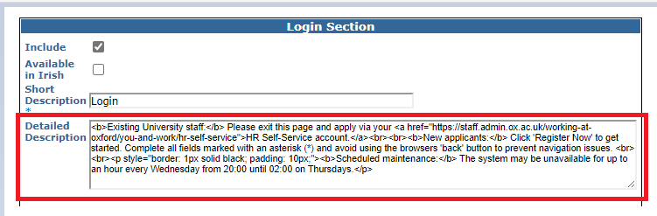

Here you can view the text and settings for the Login page. The text is entered into the Detailed Description section.

  - To make your changes, overwrite the existing text in the Detailed Description box with your new wording.
 | NB: The standard message must always be displayed below your additional text as shown in the example below. It is recommended that you add this wording to the end of your new text and paste the entire message into the Detailed Description box

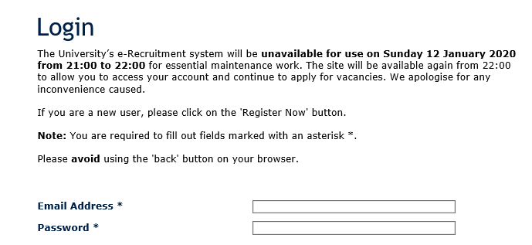

  - SAVE.

Message templates

Standard message

HTML version | Appearance on website
<b>Existing University staff:</b> Please exit this page and apply via your <a href="https://staff.admin.ox.ac.uk/working-at-oxford/you-and-work/hr-self-service">HR Self-Service account.</a><br><br><b>New applicants:</b> Click 'Register Now' to get started. Complete all fields marked with an asterisk (*) and avoid using the browsers 'back' button to prevent navigation issues. <br><br><p style="border: 1px solid black; padding: 10px;"><b>Scheduled maintenance:</b> The system may be unavailable for up to an hour every Wednesday from 20:00 until 02:00 on Thursdays.</p> | 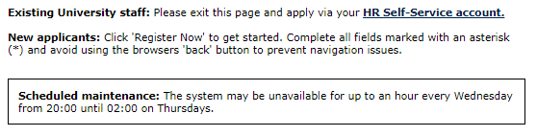

The templates below may help you when updating the text to be displayed.

Downtime message

Remember to edit the text in red before pasting into the Detailed Description box.

HTML version | Appearance on website
The University’s e-Recruitment system will be <b>unavailable for use on Tuesday 11 October 2016 between 13:00 and 20:00</b> in order that essential maintenance work can be undertaken. The site will be available again from 20:00 on Tuesday to allow you to access your account and continue to apply for vacancies. We apologise for any inconvenience caused.<br><br>  <b>Existing University staff:</b> Please exit this page and apply via your <a href="https://staff.admin.ox.ac.uk/working-at-oxford/you-and-work/hr-self-service">HR Self-Service account.</a><br><br><b>New applicants:</b> Click 'Register Now' to get started. Complete all fields marked with an asterisk (*) and avoid using the browsers 'back' button to prevent navigation issues. <br><br><p style="border: 1px solid black; padding: 10px;"><b>Scheduled maintenance:</b> The system may be unavailable for up to an hour every Wednesday from 20:00 until 02:00 on Thursdays.</p> | The University's e-Recruitment system will be unavailable for use on Tuesday 11 October 2016, between 13:00 and 20:00 in order that essential maintenance work can be undertaken. The site will be available again from 20:00 on Tuesday to allow you to access your account and continue to apply for vacancies. We apologise for any inconvenience caused.  

Closure Periods message

Remember to edit the text in red before pasting into the Detailed Description box.

HTML version | Appearance on website
<table style="background-color: #ffffe6; border: solid 1px #000000; padding : 2px; width: 100%;"><tr><td style="text-align: center; color: #000000; font-family: verdana,tahoma,arial, sans-serif; font-size: 8pt; background-color : #FFFFFF; font-weight: normal; font-style: normal; padding-bottom : 4px; background-color: #ffffe6; width: 90%;">Please note that the helpdesk will be closed from <b>4pm on Friday 18 December 2020 until 8.30am on Monday 4 January 2021</b>. We will respond to any requests for technical assistance over this period as soon as possible on our return. In the meantime, please check our <a href="https://staff.admin.ox.ac.uk/recruitment-support-faqs" target="_blank">help page</a> which may answer your query.  <b>Existing University staff:</b> Please exit this page and apply via your <a href="https://staff.admin.ox.ac.uk/working-at-oxford/you-and-work/hr-self-service">HR Self-Service account.</a><br><br><b>New applicants:</b> Click 'Register Now' to get started. Complete all fields marked with an asterisk (*) and avoid using the browsers 'back' button to prevent navigation issues. <br><br><p style="border: 1px solid black; padding: 10px;"><b>Scheduled maintenance:</b> The system may be unavailable for up to an hour every Wednesday from 20:00 until 02:00 on Thursdays.</p> | Please note that the helpdesk will be closed from 4pm on Friday 18 December 2020 until 8.30am on Monday 4 January 2021. We will respond to any requests for technical assistance over this period as soon as possible on our return. In the meantime, please check our help page which may answer your query.  

Decoding html

<br> inserts a line break (carriage return)

<b> the text between these will be in bold </b>

<i> the text between these will be italicised </i>

<p style="border: 1px solid black; padding: 10px;">the text between these will be inserted in a box</p>

